Testing

# Test strategy

To successfully test my program, I must consider all key elements of my program. For appropriate testing of my graphics and animations, I will include short video clips demonstrating how a user may navigate around the application. I will also test how different varieties of erroneous data is handled when input to the program, showing the robustness of my program as an application. I will also show the effect different SQL commands have on my database, such as updating the class in the connections table.

Order of testing:

## Sign-up

Requirements:

* All fields are required.
* The username must be more than 5 characters long, and not already in use (objective 1.2).
* The password must be more than 6 characters long (objective 1.3).
* The username must not already exist.
* The teacher connection ID must be valid (objective 1.4).

Accepted:

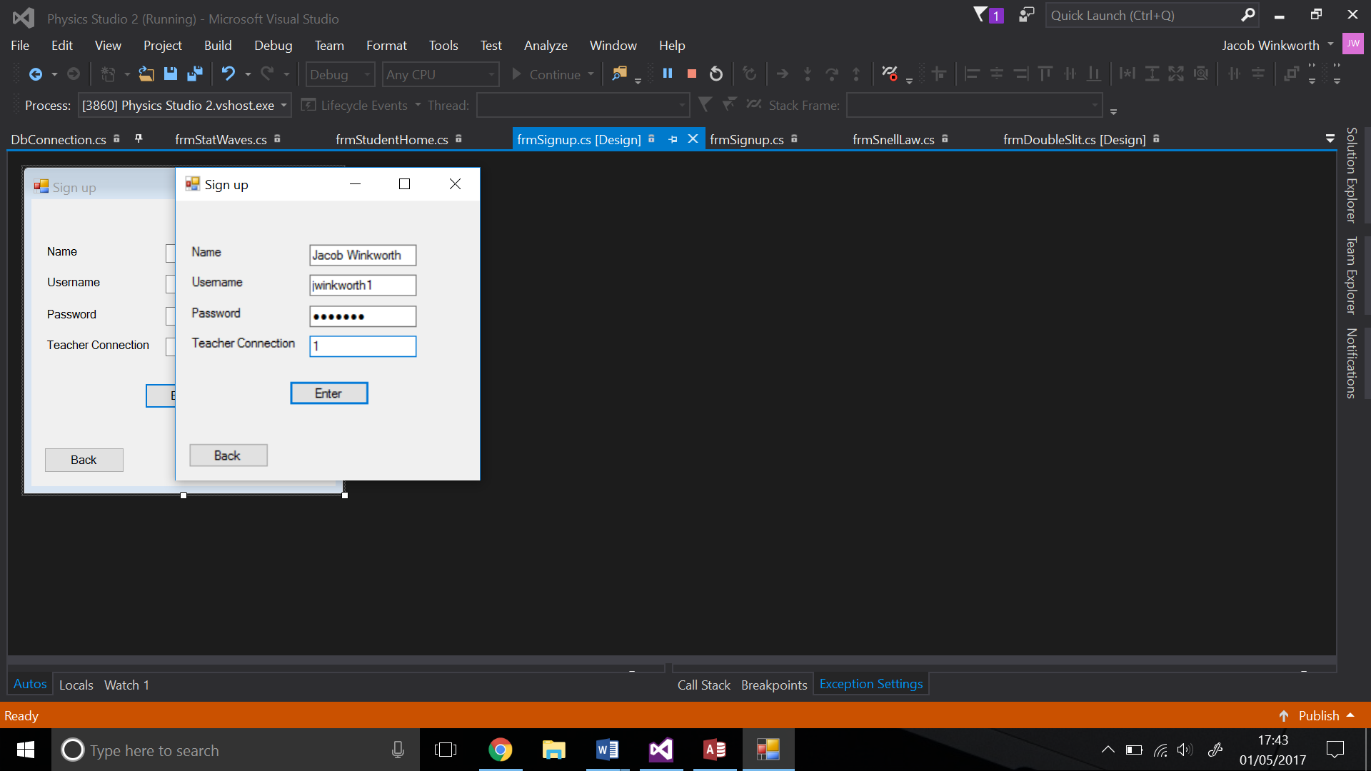

On-screen outcome:

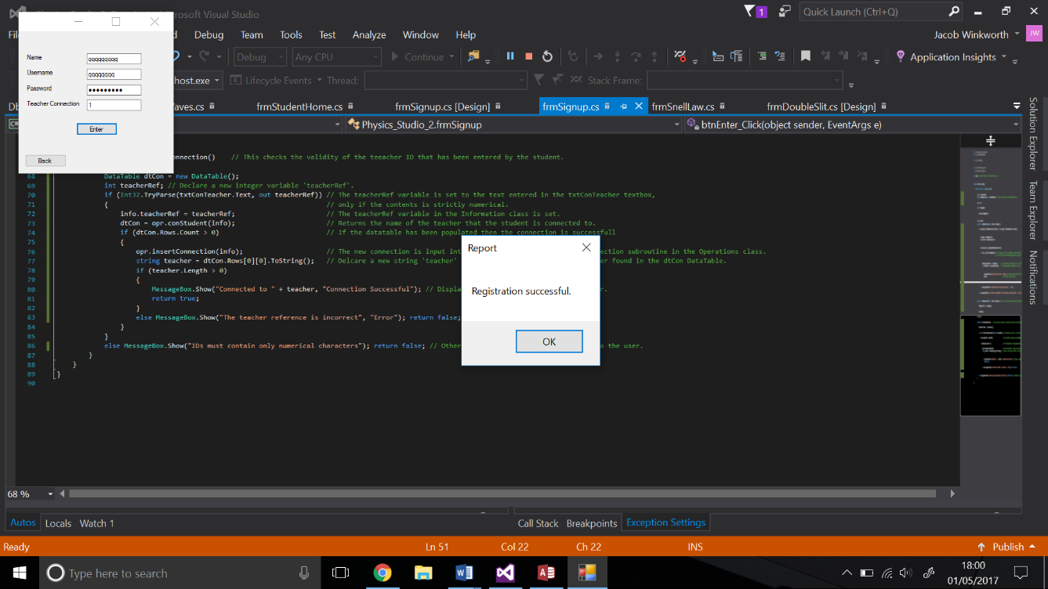

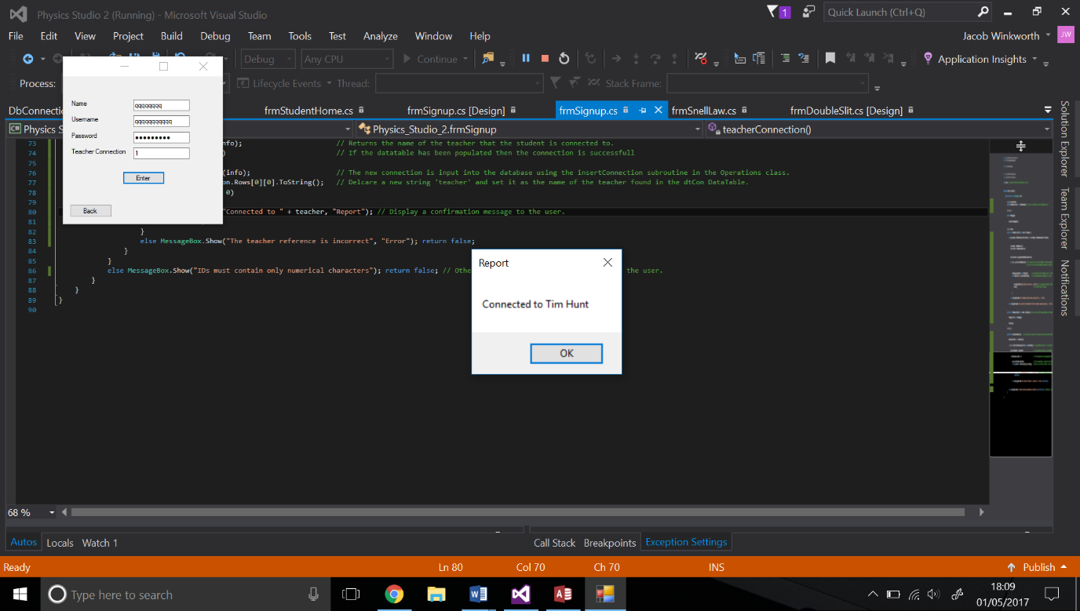

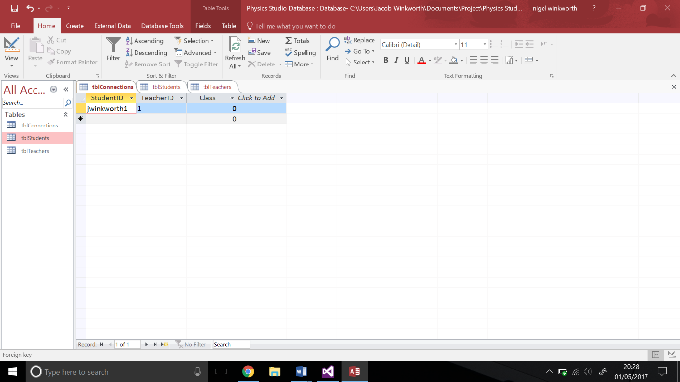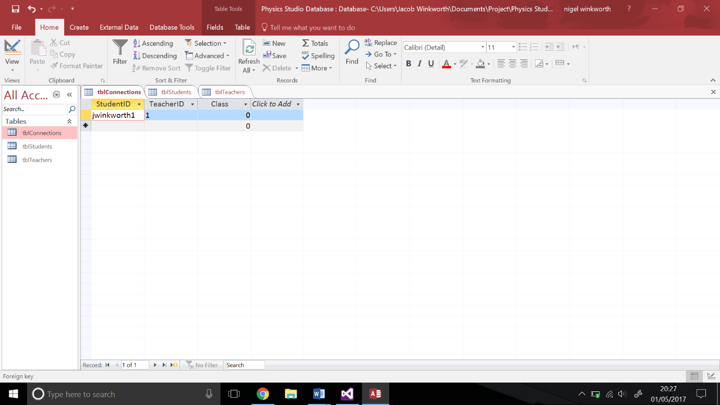Database outcome:

### Erroneous:

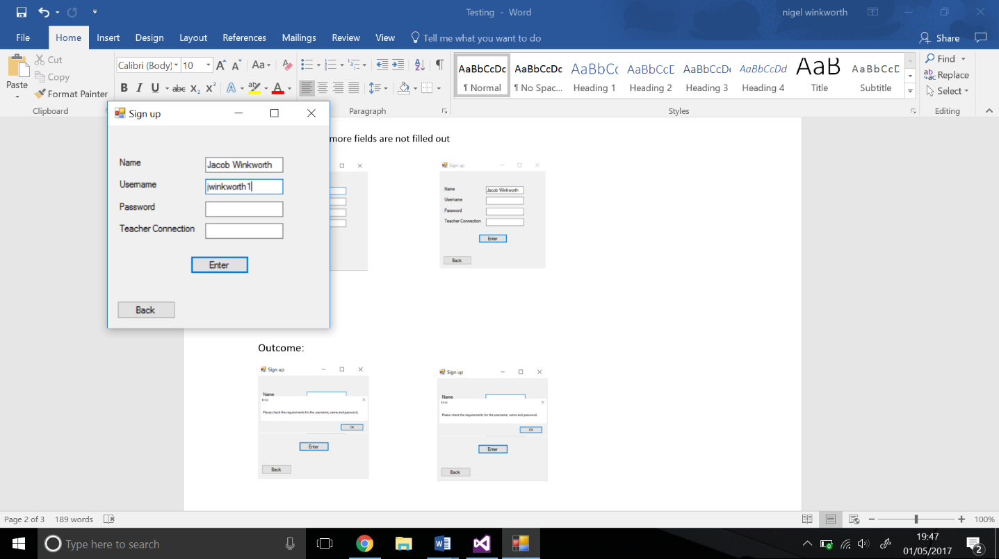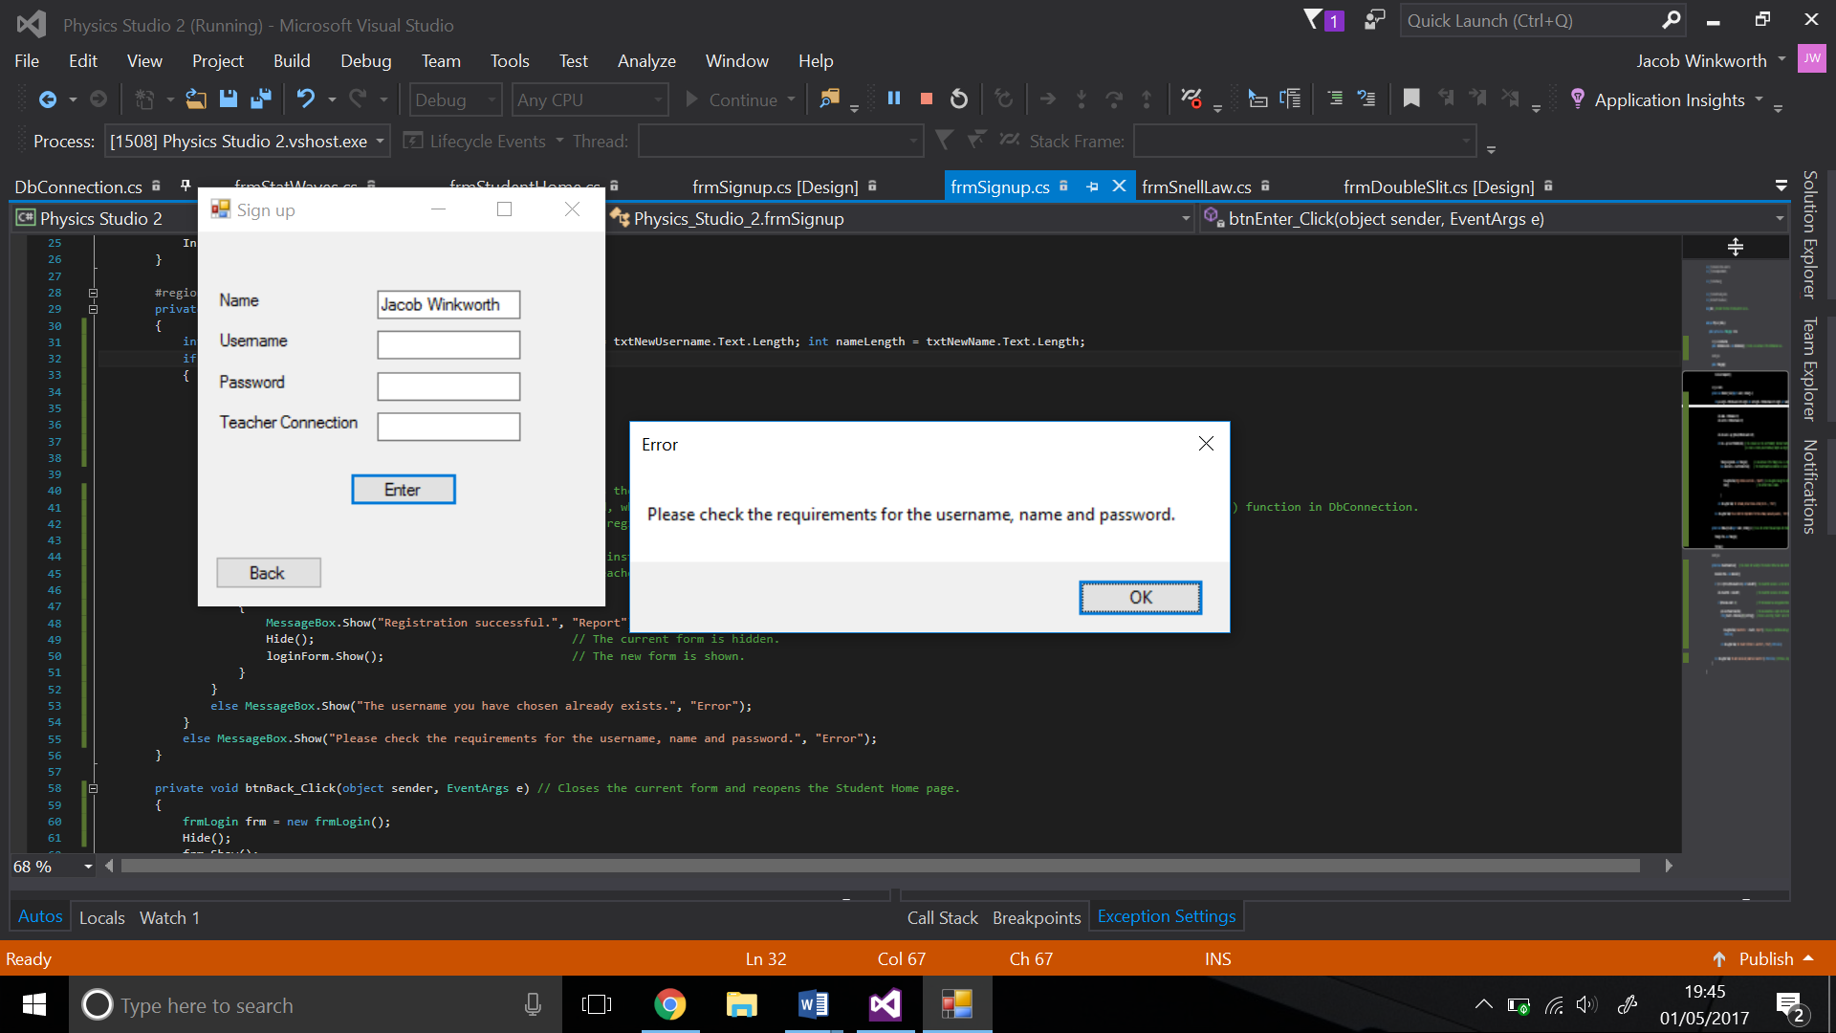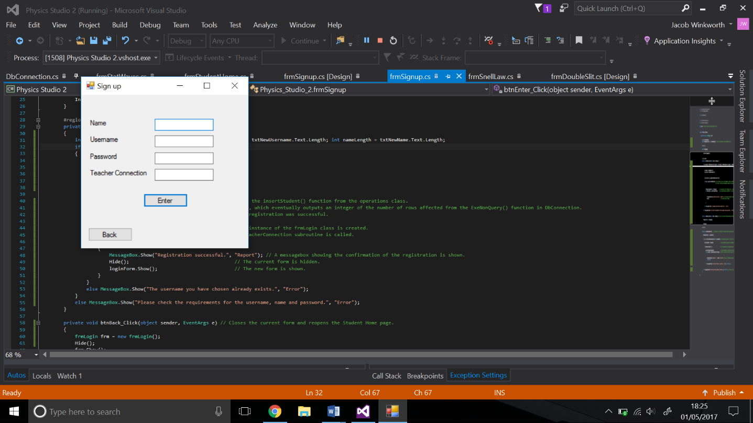Type 1: One or more fields are not filled in

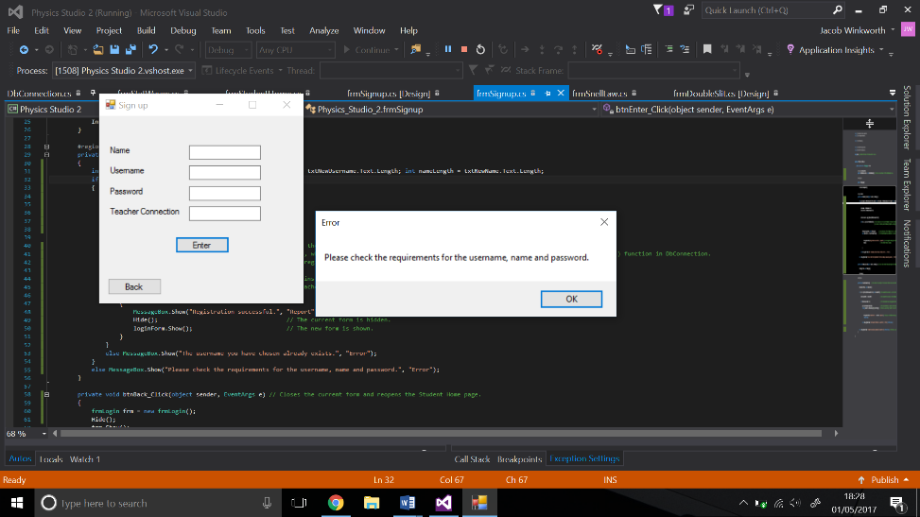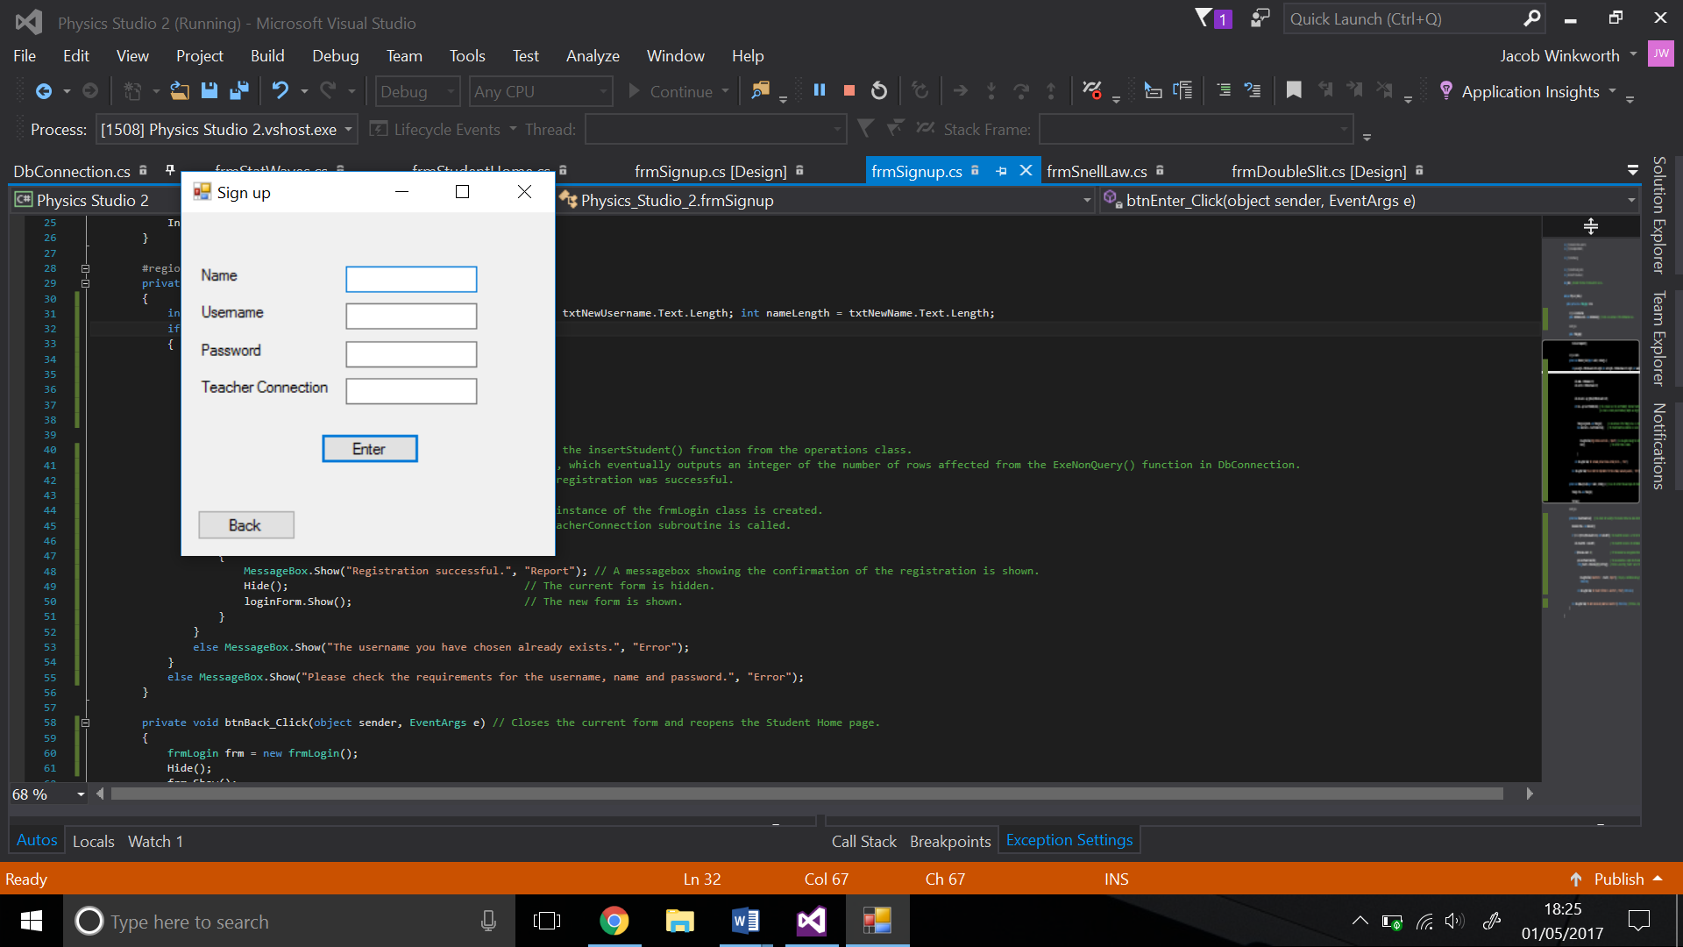Outcome:

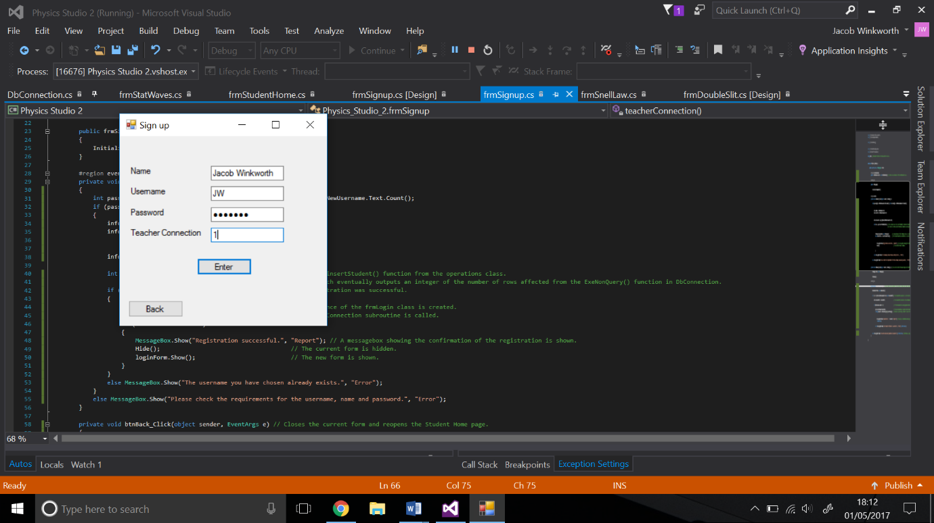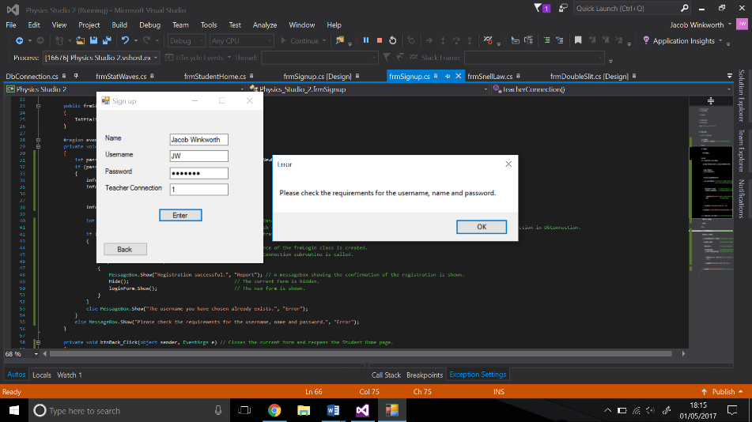Type 2: Username length too short Outcome

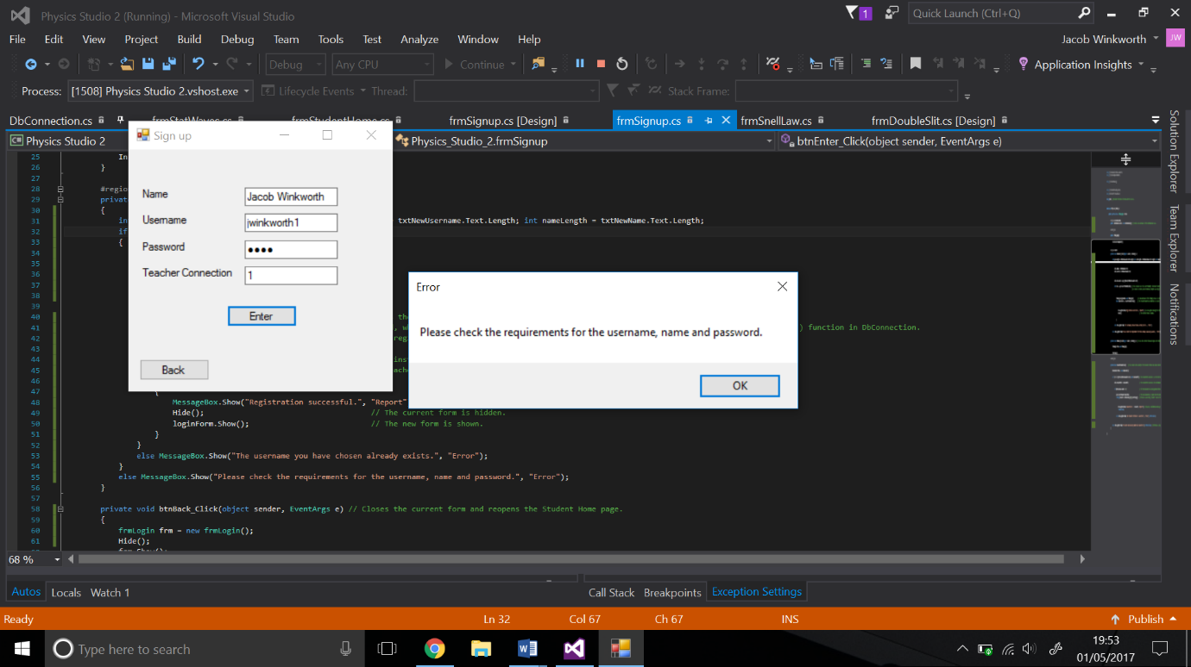Type 3: Password length too short Outcome:

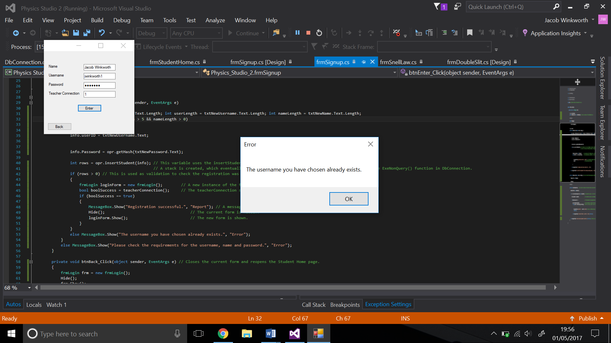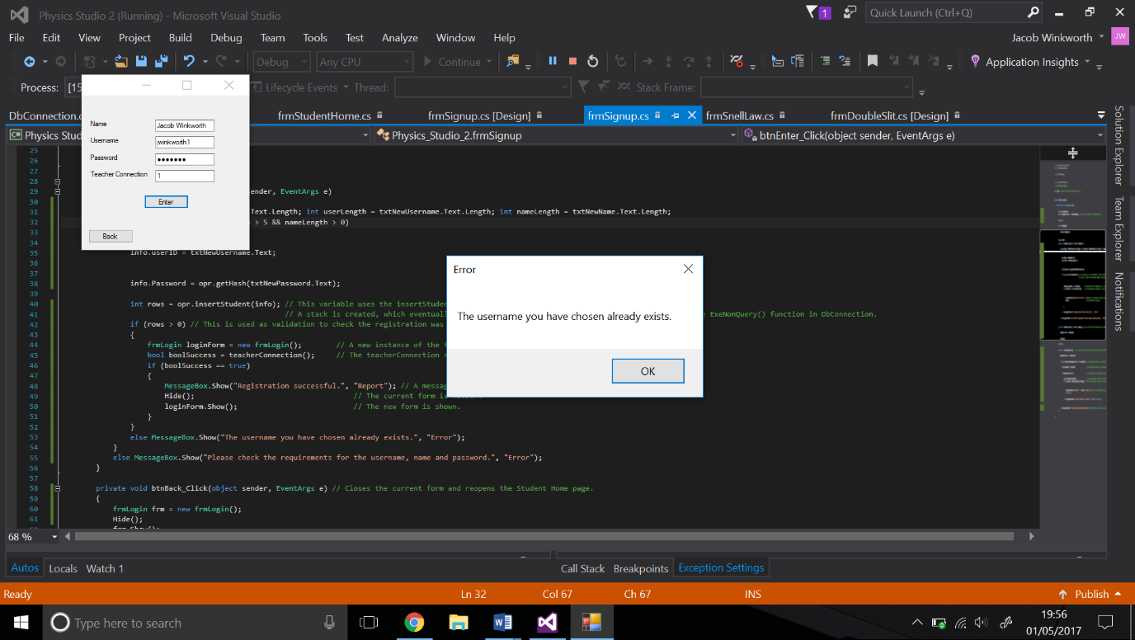Type 4: Username already exists. Outcome:

Type 5: Incorrect teacher reference Outcome:

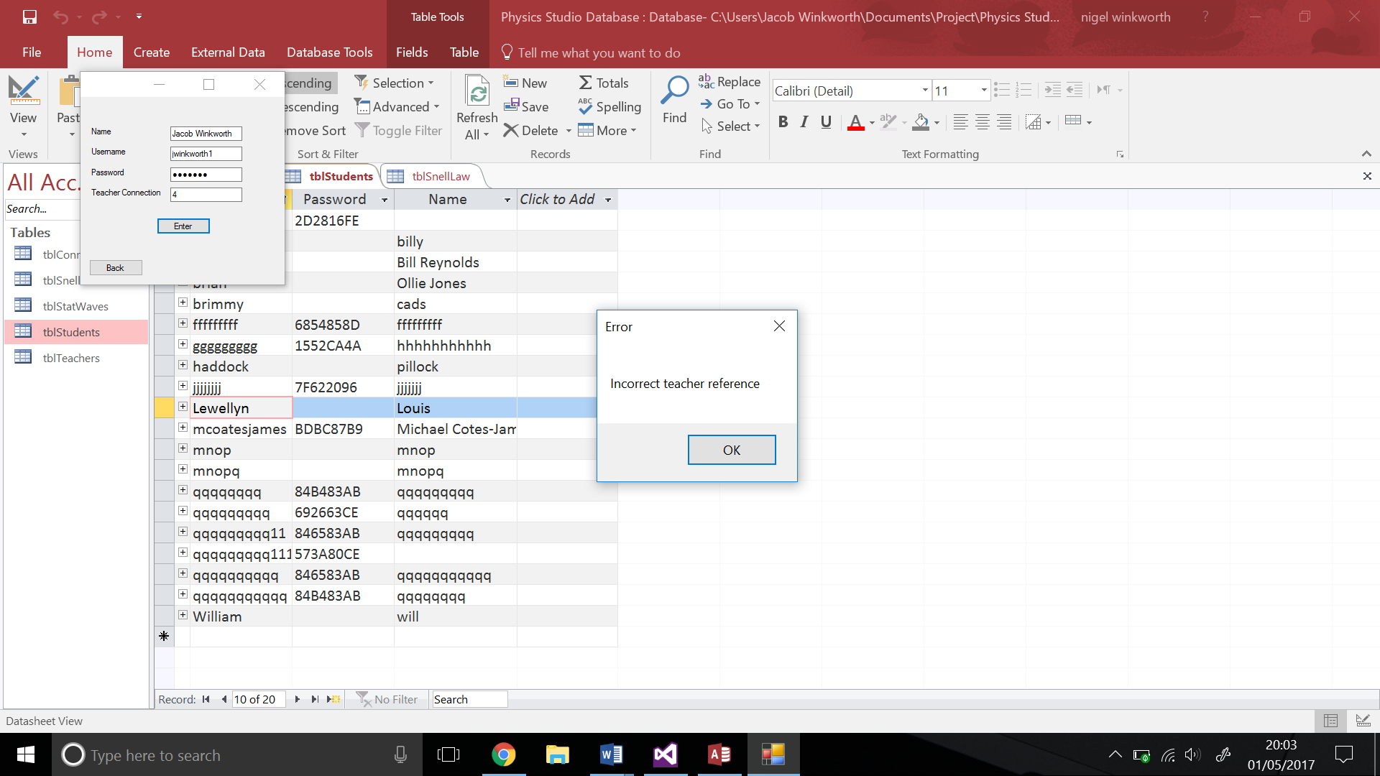

### Code

private void btnEnter_Click(object sender, EventArgs e)

{

int passLength = txtNewPassword.Text.Length; int userLength = txtNewUsername.Text.Length;

int nameLength = txtNewName.Text.Length;

if (passLength > 6 && userLength > 5 && nameLength > 0)

{

info.Name = txtNewName.Text;

info.userID = txtNewUsername.Text;

info.Password = opr.getHash(txtNewPassword.Text);

int rows = opr.insertStudent(info); // Declare a new variable and use the insertStudent() function from the operations

// class to get the number of rows affected when the query string is passed.

if (rows > 0) // This is used as validation to check. If rows were added, it means the data was inserted successfully.

{

frmLogin loginForm = new frmLogin(); // A new instance of the frmLogin class is created.

bool boolSuccess = teacherConnection(); // Declare a new boolean variable 'boolSuccess' and call the

// teacherConnection subroutine.

if (boolSuccess == true) // If the connection is successful, then the overall registration is also successful.

{

MessageBox.Show("Registration successful.", "Report"); // A messagebox showing the confirmation of the registration

// is shown.

Hide(); // The current form is hidden.

loginForm.Show(); // The new form is shown.

}

}

// If the connection is not successful, and boolSuccess is false, the chosen username must already be in use.

else MessageBox.Show("The username you have chosen already exists.", "Error");

}

// If the requirements are not met, display an error message.

else MessageBox.Show("Please check the requirements for the username, name and password.", "Error");

}

private bool teacherConnection() // This checks the validity of the teeacher ID that has been entered by the student.

{

DataTable dtCon = new DataTable();

int teacherRef; // Declare a new integer variable 'teacherRef'.

if (Int32.TryParse(txtConTeacher.Text, out teacherRef)) // The teacherRef variable is set to the text entered in the

{ // txtConTeacher textbox, only if the contents is strictly numerical.

info.teacherRef = teacherRef; // The teacherRef variable in the Information class is set.

dtCon = opr.conStudent(info); // Returns the name of the teacher that the student is connected to.

if (dtCon.Rows.Count > 0) // If the datatable has been populated then the connection is successful.

{

opr.insertConnection(info); // The new connection is input into the database using the insertConnection subroutine

// in the Operations class.

string teacher = dtCon.Rows[0][0].ToString(); // Declare a new string 'teacher' and set it as the name of the teacher

// found in the dtCon DataTable.

if (teacher.Length > 0) // If the length of this string is more than zero, it means a value has been successfully returned.

{

MessageBox.Show("Connected to " + teacher, "Report"); // Display a confirmation message to the user.

return true;

}

// If the length of the string is not greater than 0, it means the teacher reference was incorrect. A value of false is returned

else MessageBox.Show("Incorrect teacher reference", "Error"); return false;

}

}

// If the ID entered was not strictly numerical, display an error message. A value of false is returned.

else MessageBox.Show("IDs must contain only numerical characters"); return false;

}

**The highlighted sections above show areas where error handling is taking place.**

## Login

Accepted: Outcome:

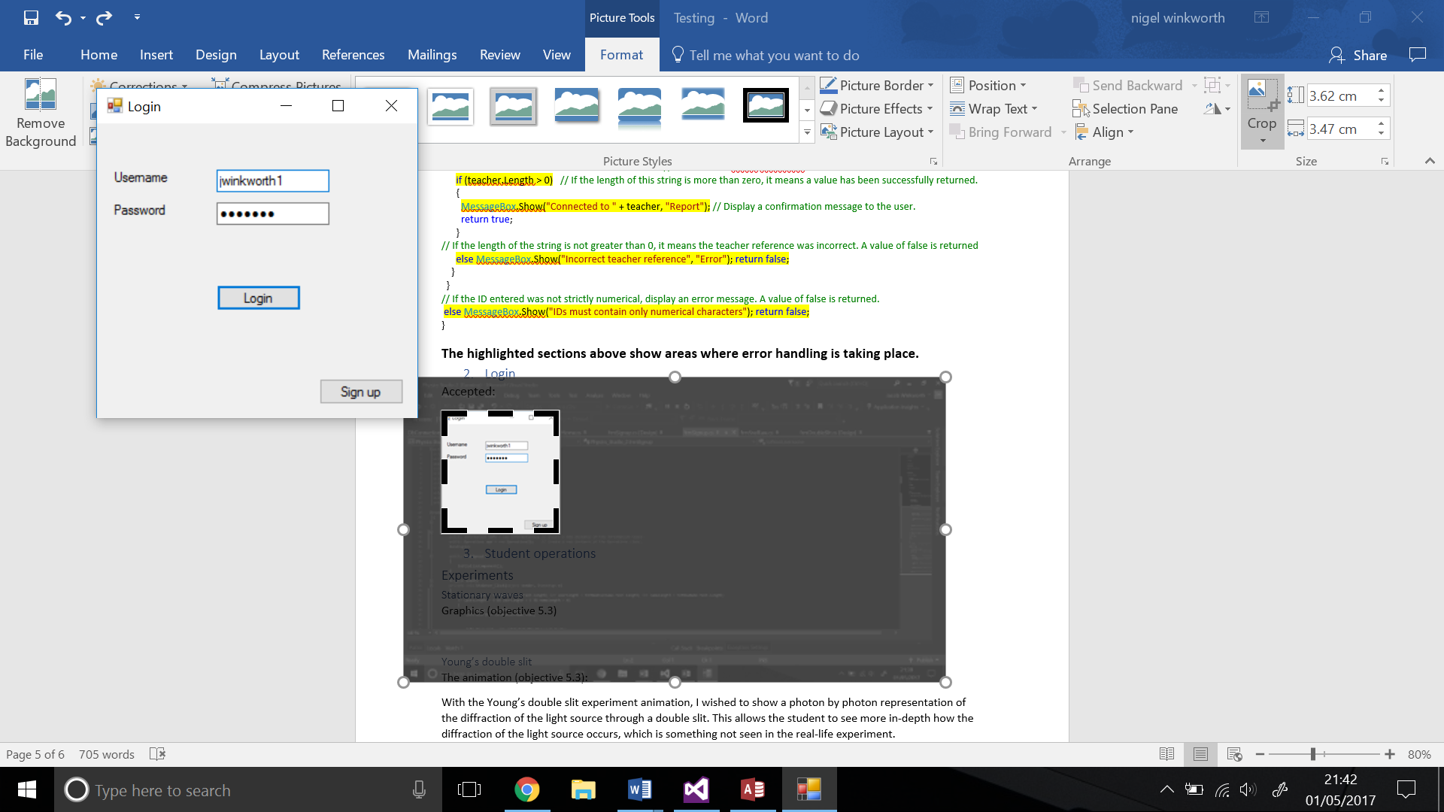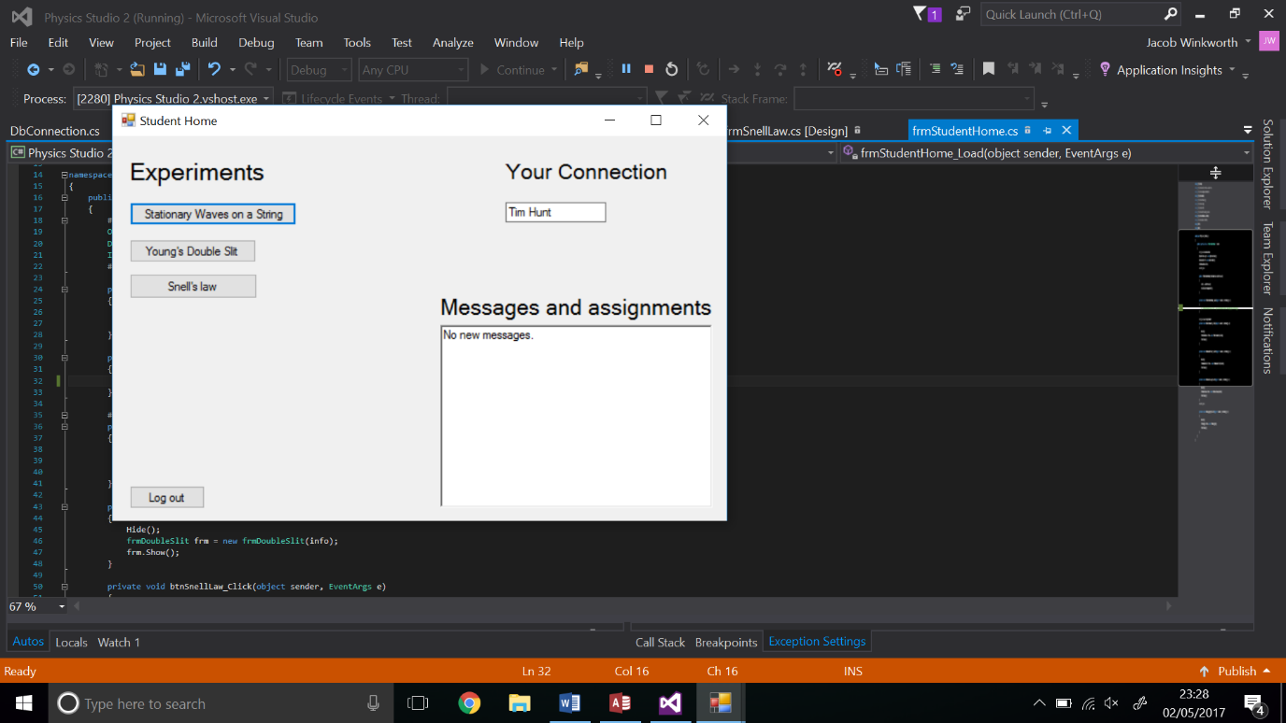

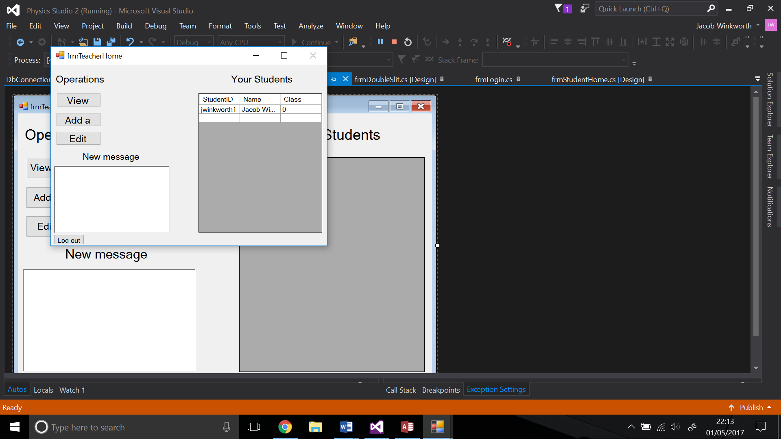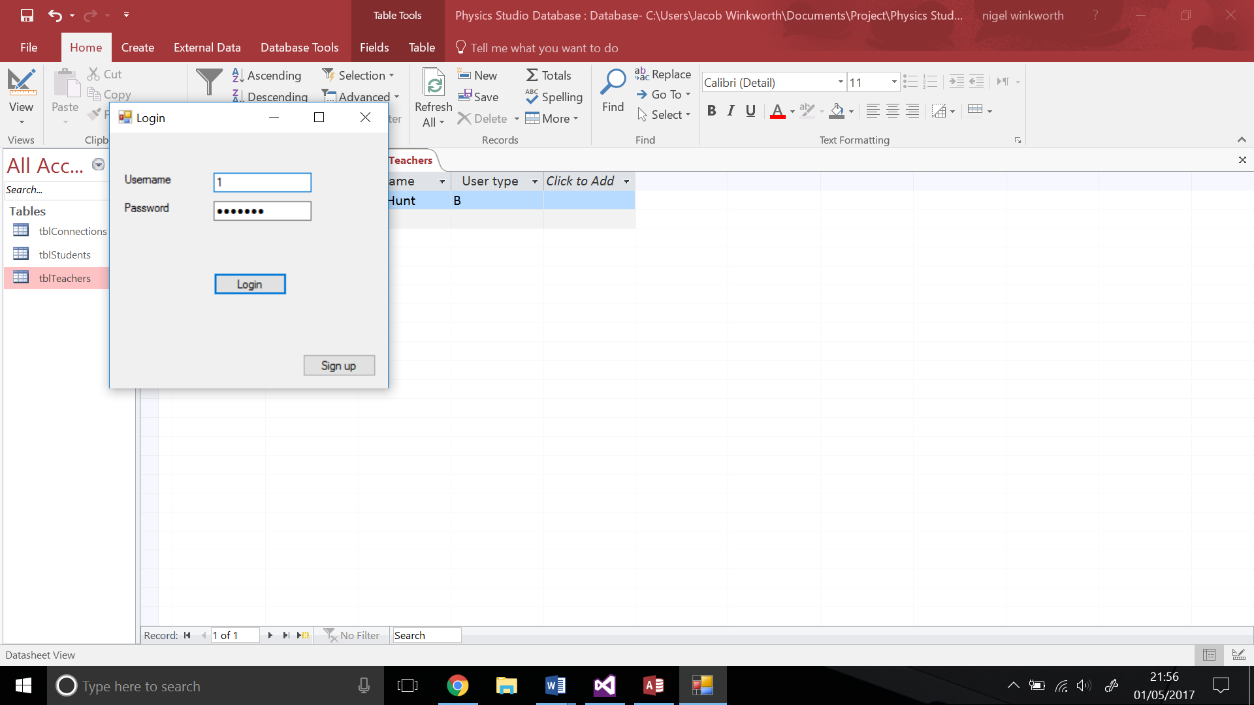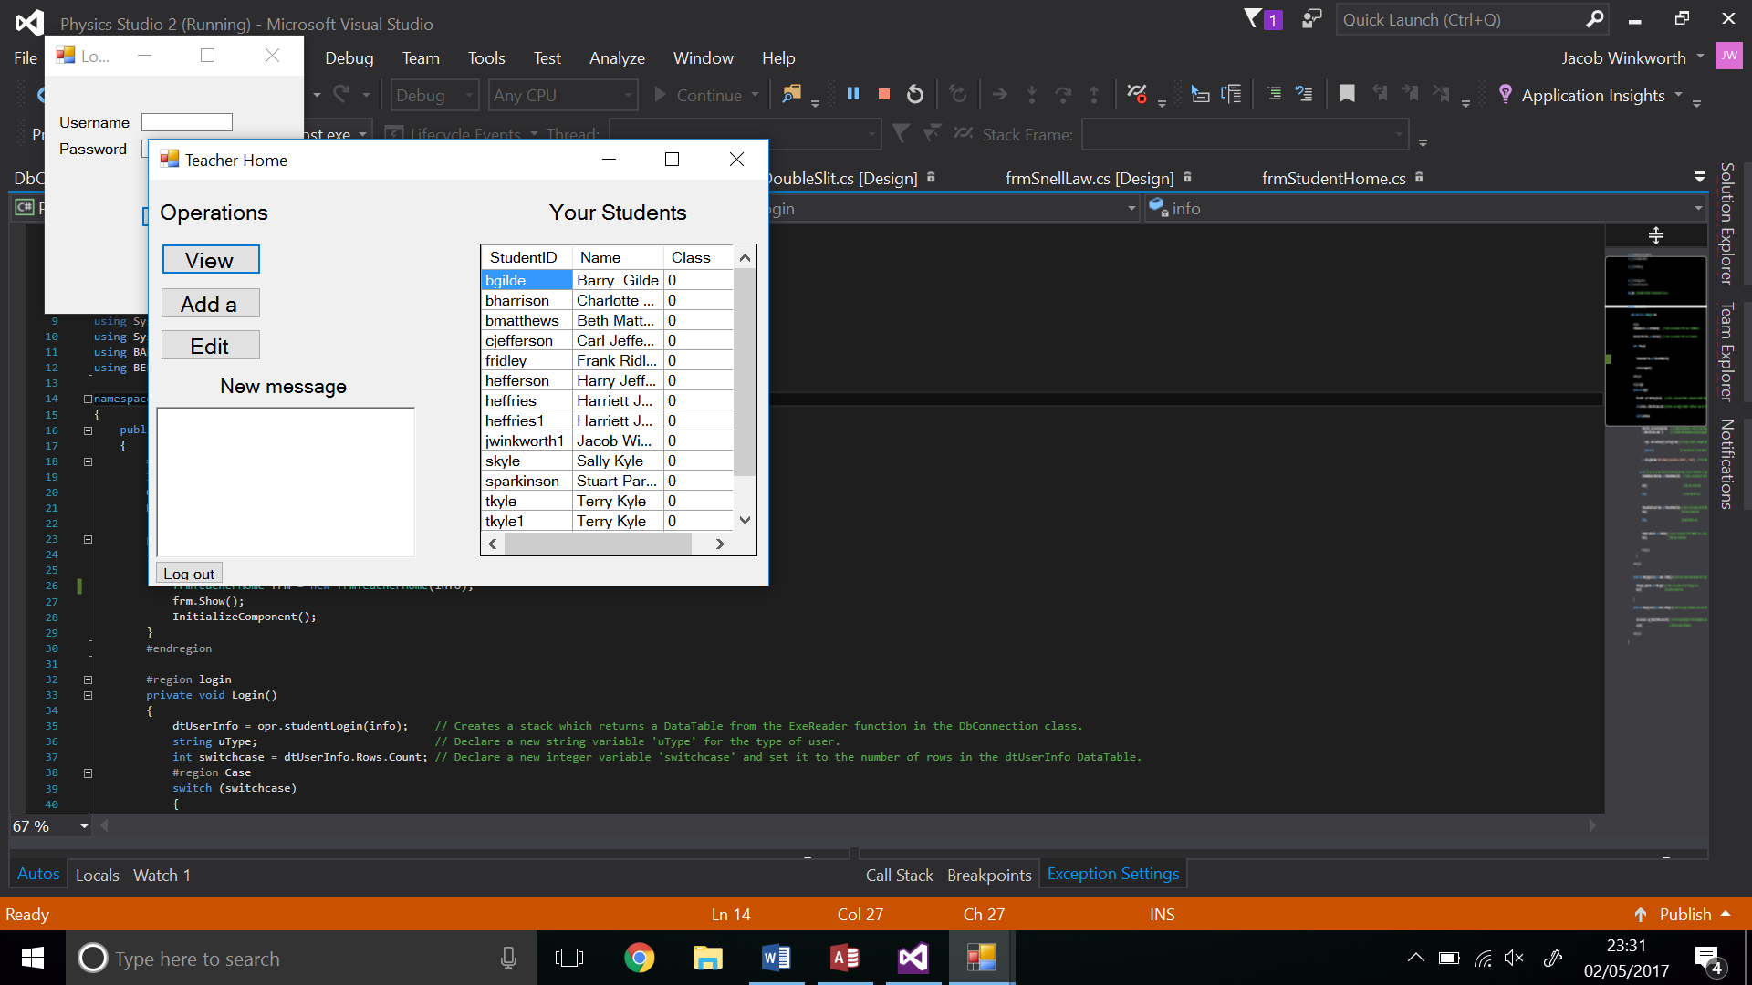Accepted: Outcome:

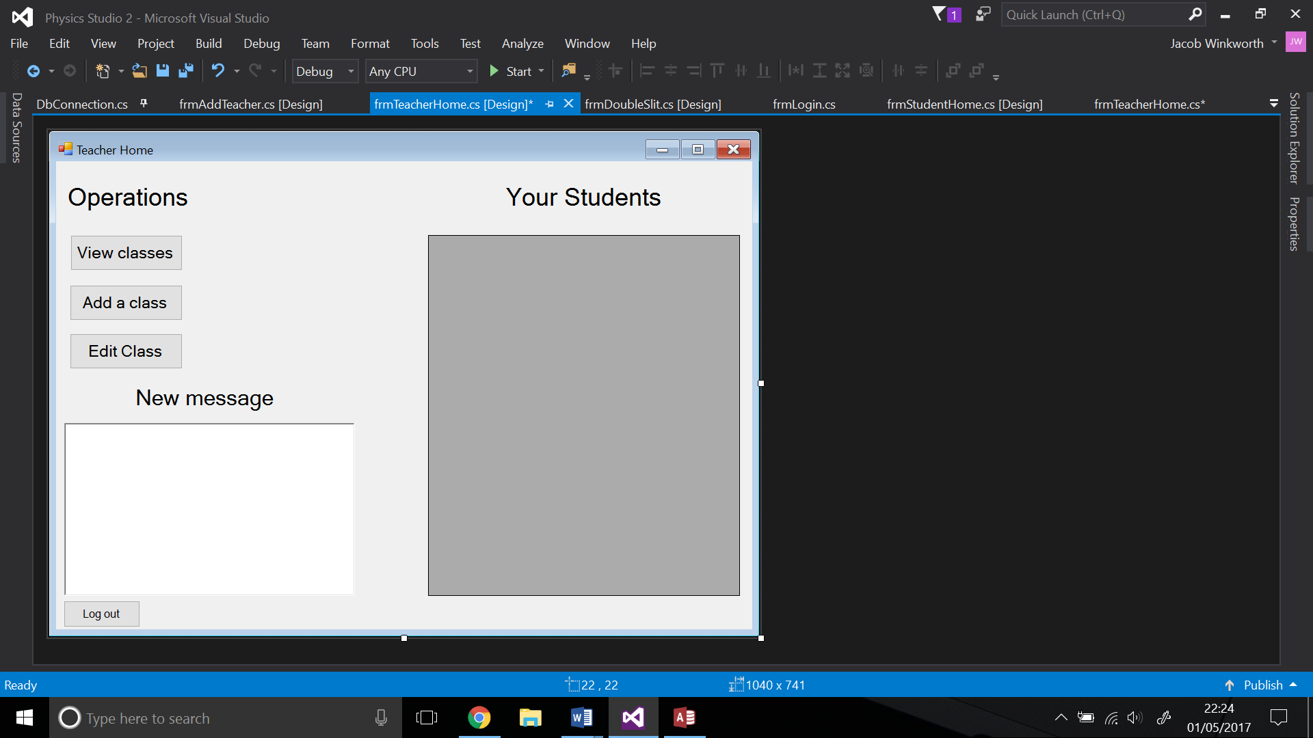

### Erroneous:

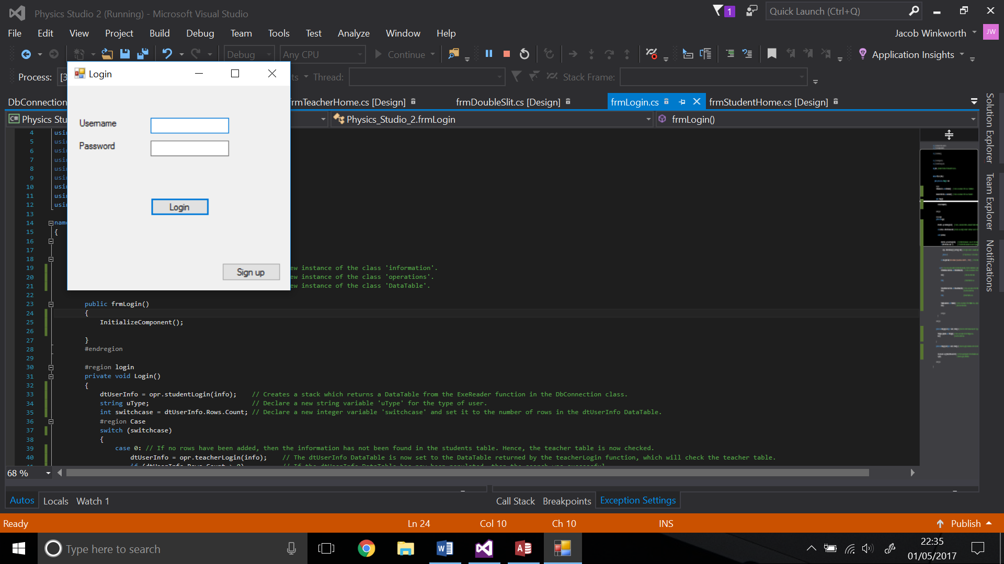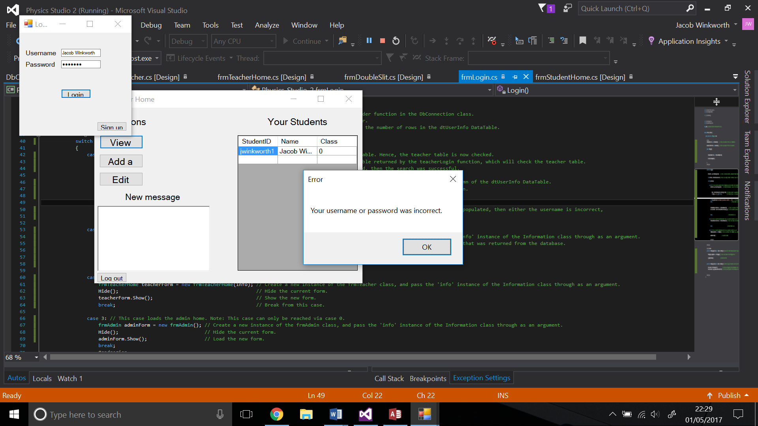Type 1: Empty textboxes Outcome:

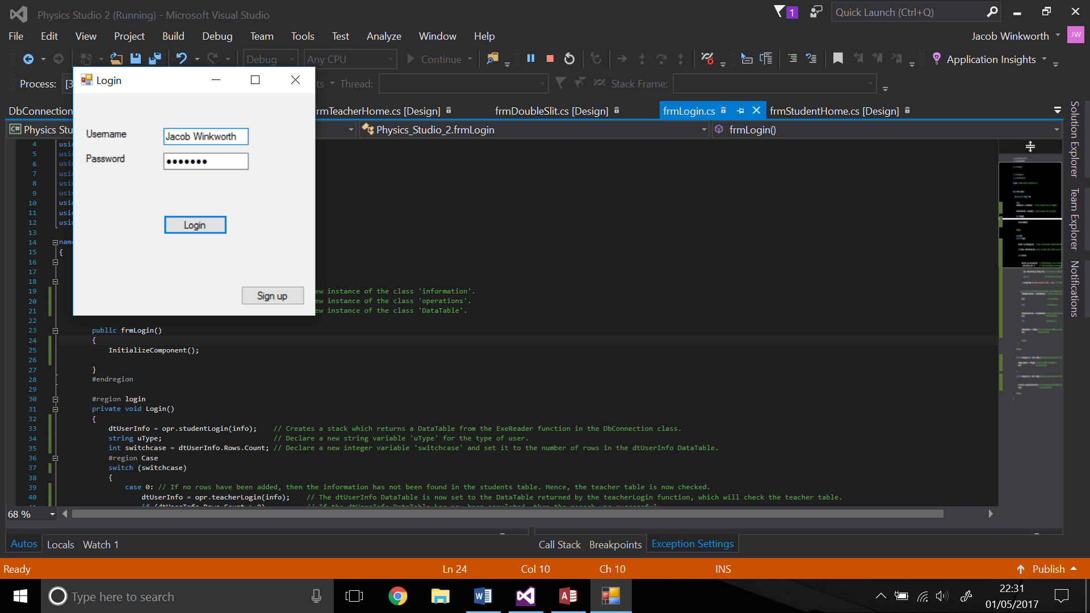Type 2: Incorrect username or password Outcome:

Code

private void Login()

{

dtUserInfo = opr.studentLogin(info); // Creates a stack which returns a DataTable from the ExeReader function in the

// DbConnection class.

string uType; // Declare a new string variable 'uType' for the type of user.

int switchcase = dtUserInfo.Rows.Count; // Declare a new integer variable 'switchcase' and set it to the number of rows in

// the dtUserInfo DataTable.

switch (switchcase)

{

case 0: // If no rows are added to the table, the information has not been found. Now, the teacher table is checked.

dtUserInfo = opr.teacherLogin(info); // The dtUserInfo DataTable is now set to the DataTable returned by the

// teacherLogin function, which will check the teacher table.

if (dtUserInfo.Rows.Count > 0) // If the dtUserInfo DataTable has now been populated, then the search was successful.

{

uType = dtUserInfo.Rows[0][3].ToString().Trim(); // The uType variable is now made equal to the value found in the 4th

// column of the dtUserInfo DataTable.

if (uType == "A") { goto case 3; } // If the user type is "A", then case 3 is run. Hence, the user is an admin.

goto case 2; // If not, then case 2 is run. Hence, the user is a regular teacher.

}

// If the dtUserInfo DataTable has still not been populated, then either the username is incorrect, the passsword is incorrect, or both are incorrect.

else MessageBox.Show("Your username or password was incorrect.", "Error");

break;

case 1: // If one row has been added to the dtUserInfo DataTable, then the student home is loaded.

frmStudentHome studentForm = new frmStudentHome(info); // Create a new instance of the frmStudentHome class.

info.teacherRef = Convert.ToInt32(dtUserInfo.Rows[0][2]); // Set the teacherRef variable in the Information class as the

// value that was returned from the database.

Hide(); // Hide the current form.

studentForm.Show(); // Show the new form.

break; // Break from this case.

case 2: // This case loads the teacher home. Note: This case can only be reached via case 0.

frmTeacherHome teacherForm = new frmTeacherHome(info); // Create a new instance of the frmTeacher class.

Hide(); // Hide the current form.

teacherForm.Show(); // Show the new form.

break; // Break from this case.

case 3: // This case loads the admin home. Note: This case can only be reached via case 0.

frmAdmin adminForm = new frmAdmin(); // Create a new instance of the frmAdmin class.

Hide();// Hide the current form.

adminForm.Show(); // Load the new form.

Break;

}

}

**The highlighted sections above show areas where error handling is taking place.**

## Student operations

### Experiments

#### Stationary waves

Graphics (objective 5.3)

With the stationary waves experiment, I wished to show a variety of different harmonics on display. I included six of these harmonics, with the user being able to switch between them using the combo box labelled ‘Harmonic’. These allows the user to grasp an idea of how this experiment may look in real life.

Recording results (objective 5.3)

Each time the Plot button is clicked, the data shown by the sliders is recorded in the DataGridView, and plotted on the graph. The user is also able to switch between plotting the inverse of the frequency against the length of the wire, and the square of the frequency against the tension in the wire.

Each of these are demonstrated in the video below:

#### Young’s double slit

The animation (objective 5.3):

With the Young’s double slit experiment animation, I wished to show a photon by photon representation of the diffraction of the light source through a double slit. This allows the student to see more in-depth how the diffraction of the light source occurs, which is something not seen in the real-life experiment.

Recording results (objective 5.4):

Each time the Start button is clicked, the data input by the user is recorded in the DataGridView, along with the correct graph being shown to represent that particular diffraction pattern.

Each of these are demonstrated in the video below:

https://youtu.be/DGCMoCFnpiI

#### Snell’s law

The animation (objective 5.3)

With the Snell’s law experiment animation, I wished to show a realistic interpretation of how a light source would pass between two different mediums. For the animation to be successful, I had to consider the different refractive indexes of the two mediums. I also had to ensure that when the critical angle was met, the light would undergo total internal reflection and be reflected away.

Recording results (objective 5.4)

Each time the Plot button is clicked, the data shown by the sliders and labels is recorded in the DataGridView, as well as plotting these points on the graph.

#### Saving results

Expected:

When the ‘Save’ button is clicked, the DataGridView of results should be converted into a JSON string and saved to a text file in the appropriate folder.

Accepted:

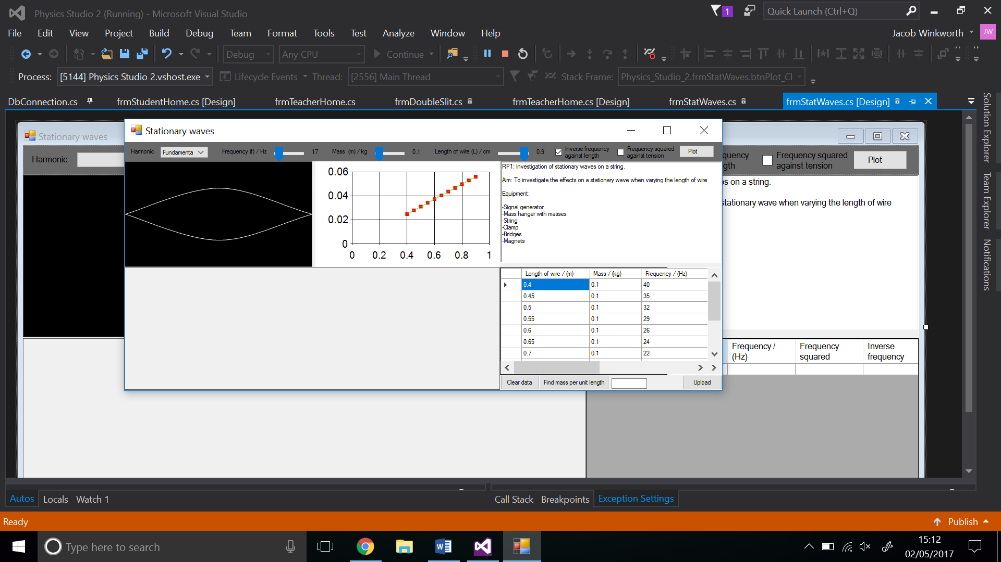

Outcome:

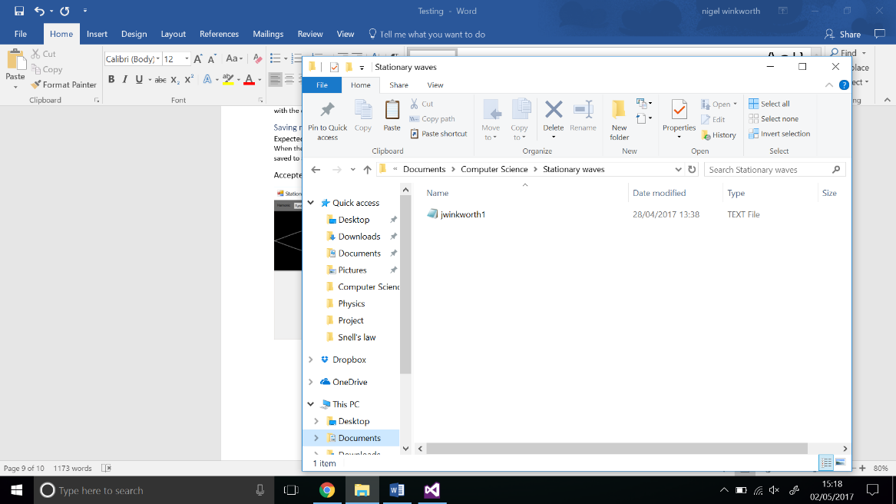File is saved to relevent folder named after the experiment.

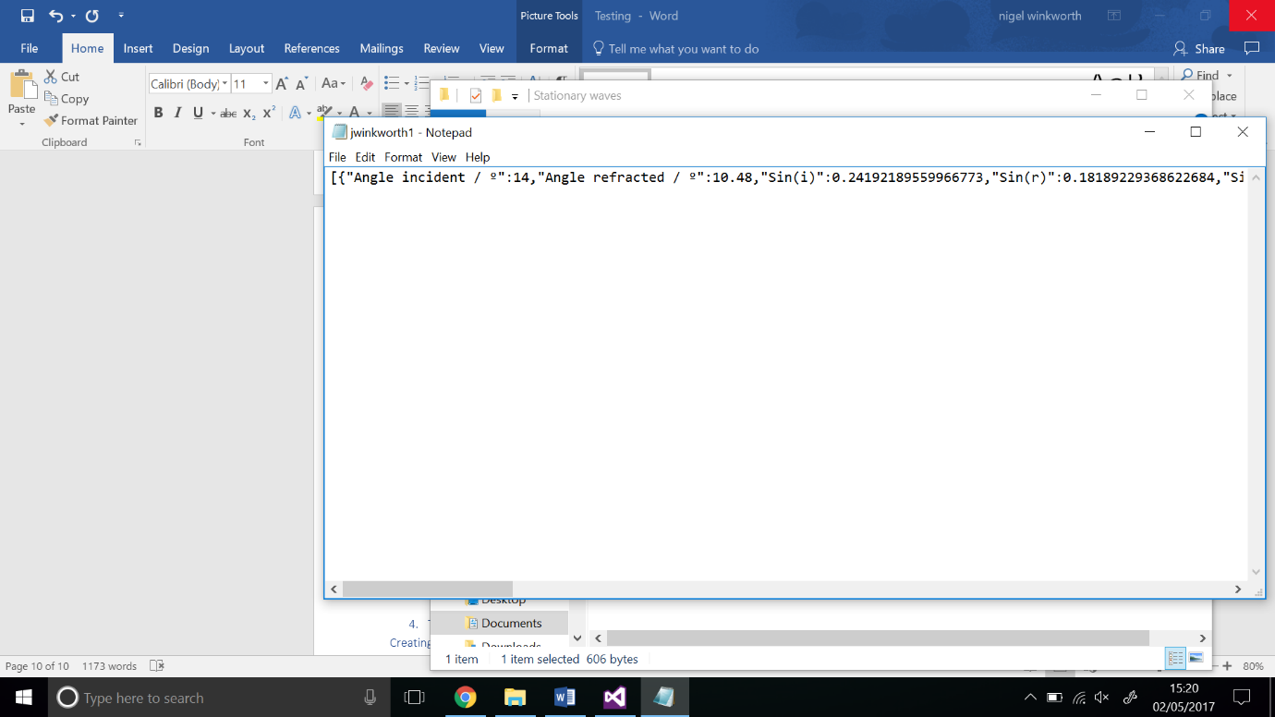The JSON string stores the information for the DataGridView

Erroneous: Blank DataGridView.

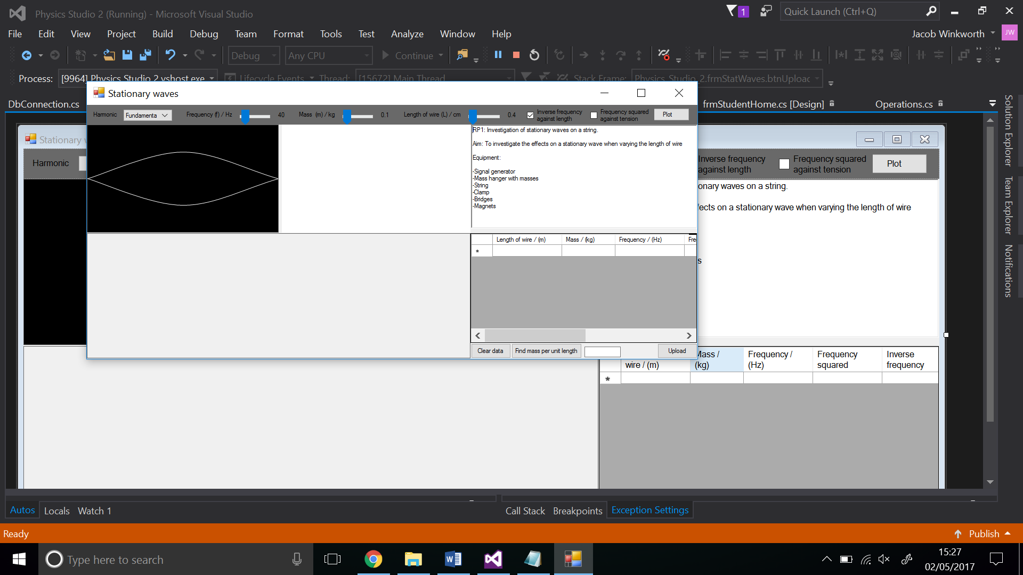

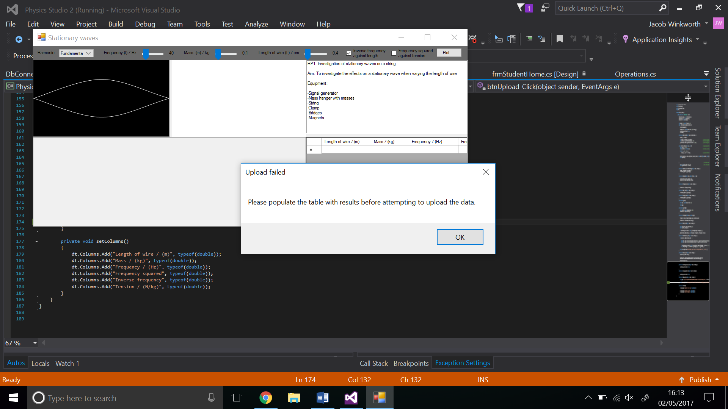Outcome:

##### Code

private void btnUpload_Click(object sender, EventArgs e)

{

string path = @"C:\Users\Jacob Winkworth\Documents\Computer Science\Stattionary” +

Waves\" + info.userID + ".text";

string json = opr.ConvertDataTabletoJSON(dt);

try { System.IO.File.WriteAllText(path, json); }

catch { MessageBox.Show("Please populate the table with results before attempting to”

+ “upload the data.", "Upload failed"); }

}

**The highlighted sections above show areas where error handling is taking place.**

#### Loading results

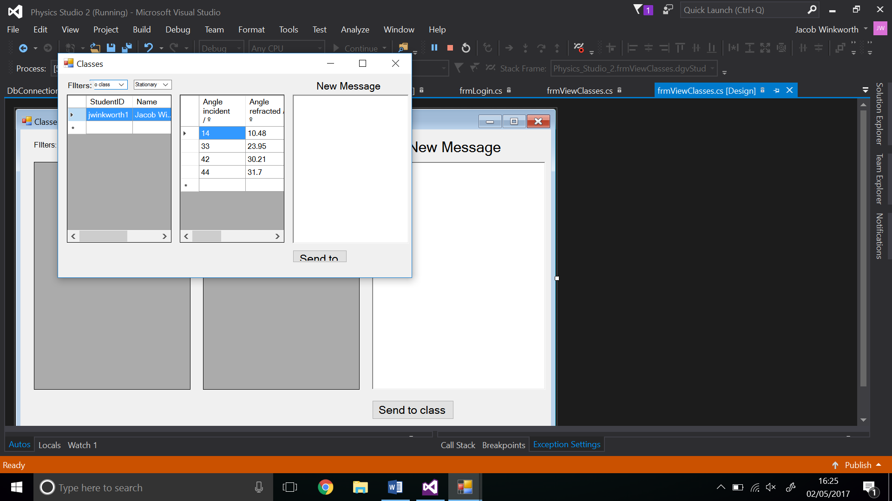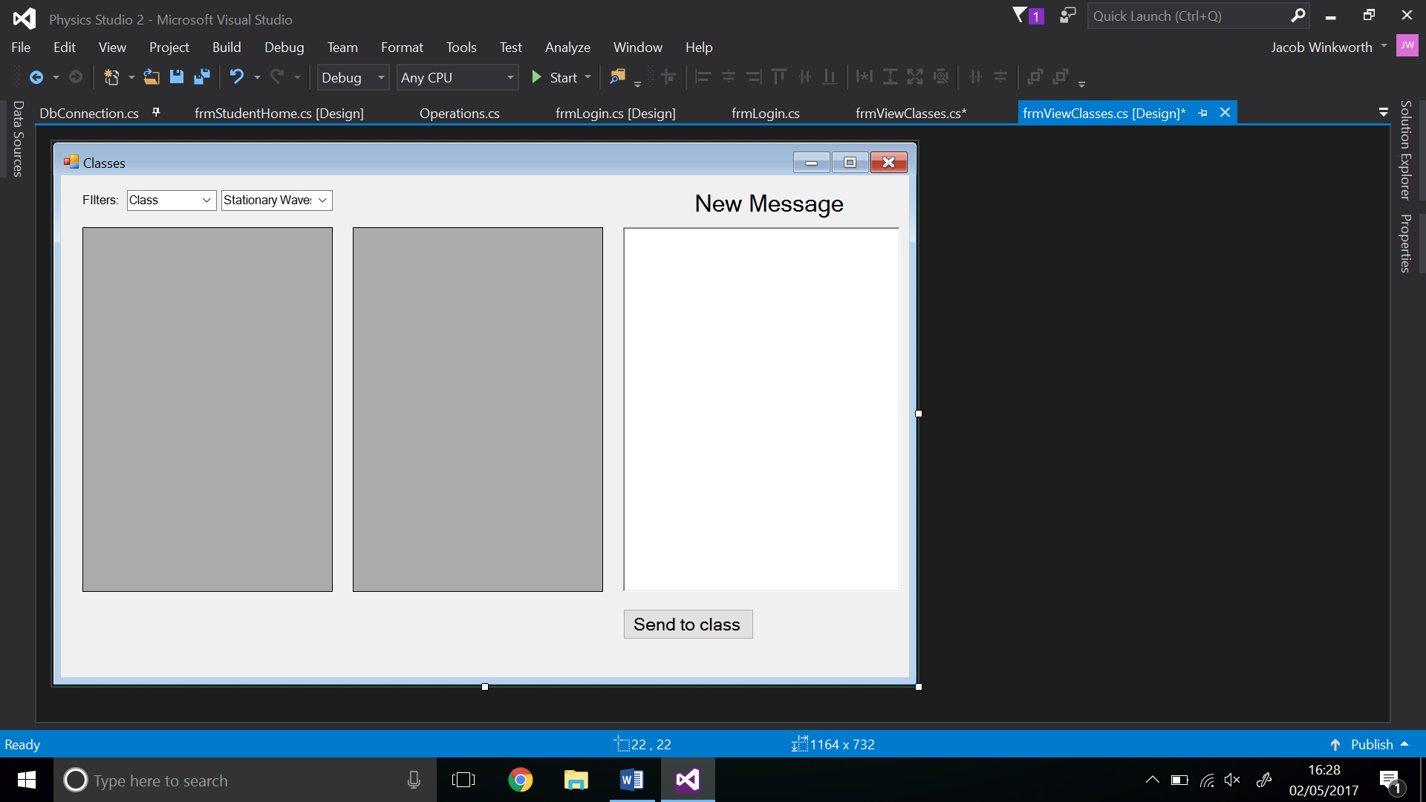Accepted:

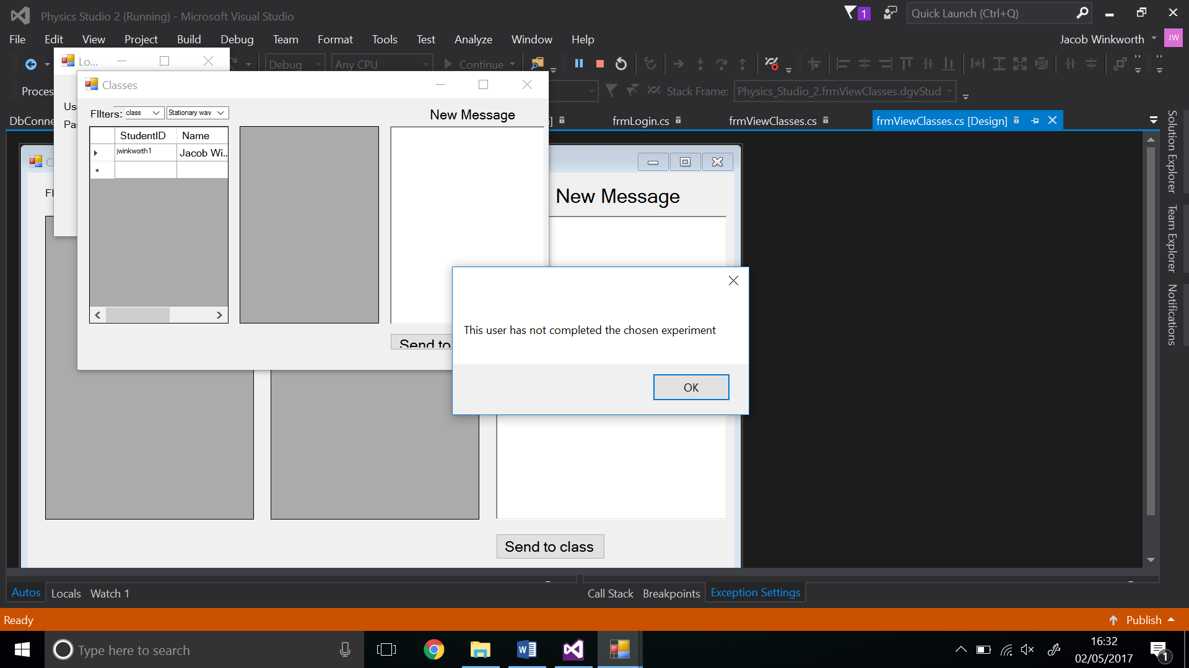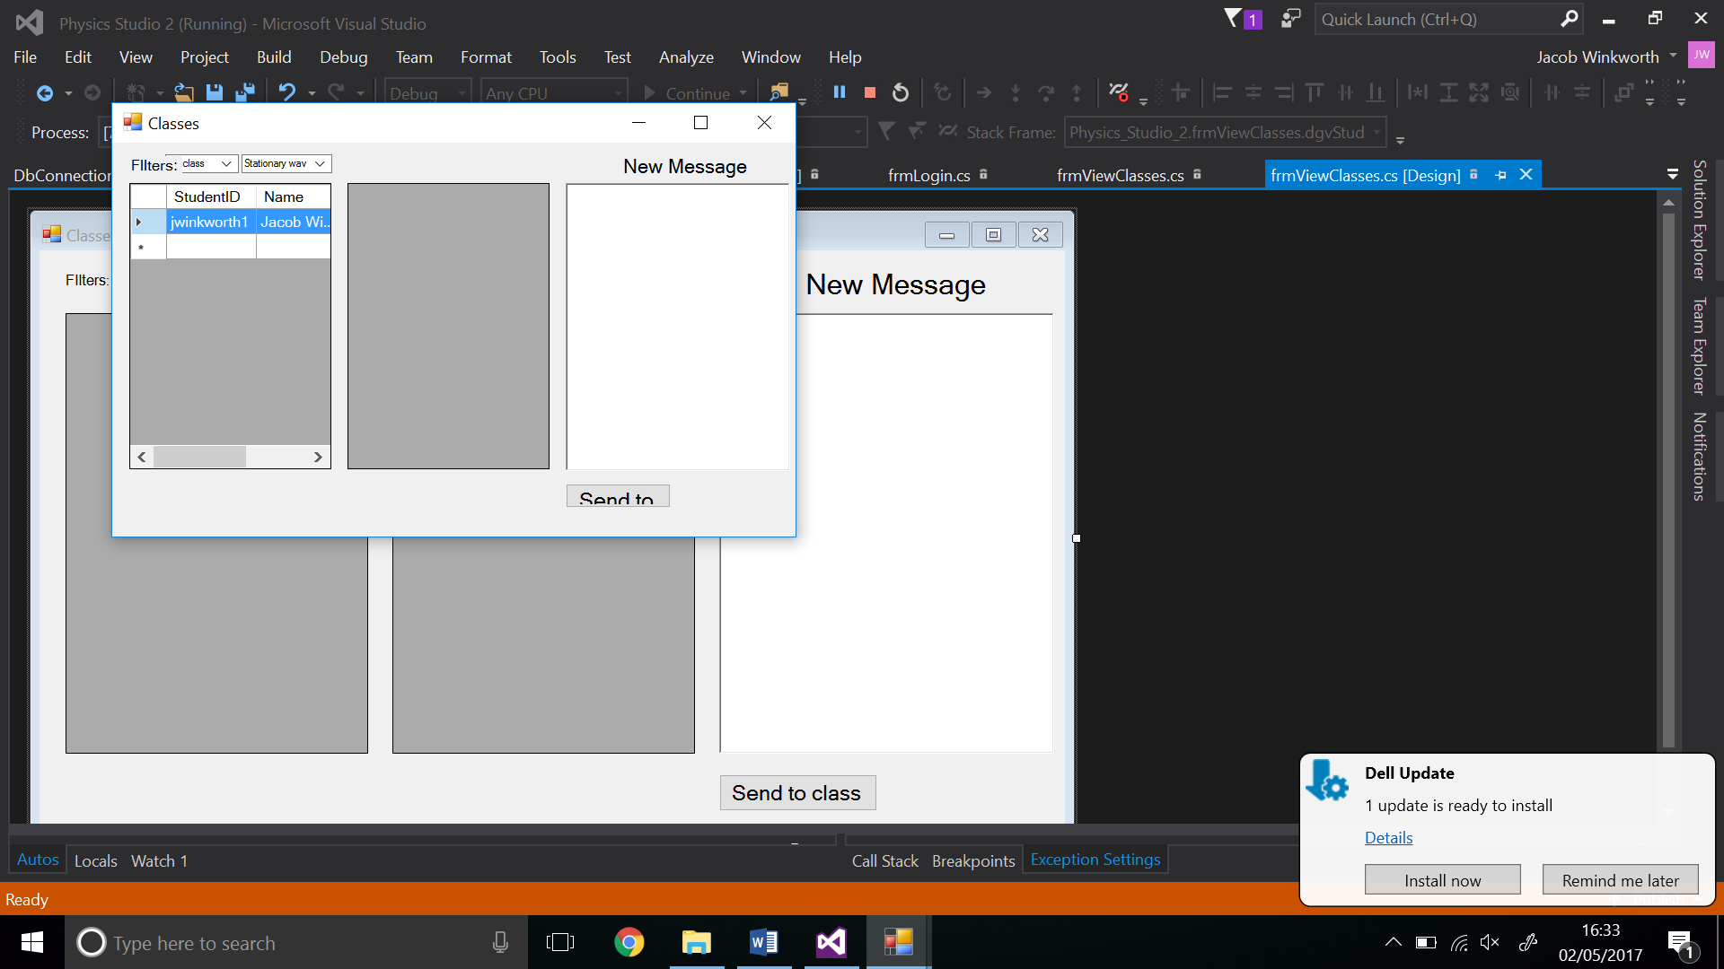Erroneous: File path not found.

##### Code

private void dgvStudents_CellContentDoubleClick(object sender, DataGridViewCellEventArgs e)

{

string folder = cbFilterExperiments.SelectedItem.ToString();

string username = dgvStudents.Rows[e.RowIndex].Cells[0].Value.ToString();

try

{

string jsonString = System.IO.File.ReadAllText(@"C:\Users\Jacob” +

“Winkworth\Documents\Computer Science\" + folder + @"\" + username + ".text");

DataTable dtResults = JsonConvert.DeserializeObject<DataTable>(jsonString);

dgvLoadResults.DataSource = dtResults;

}

catch { MessageBox.Show("This user has not completed the chosen experiment"); }

}

**The highlighted sections above show areas where error handling is taking place.**

## Teacher operations

### Creating a new class

Searching for a student (objective 4.3)

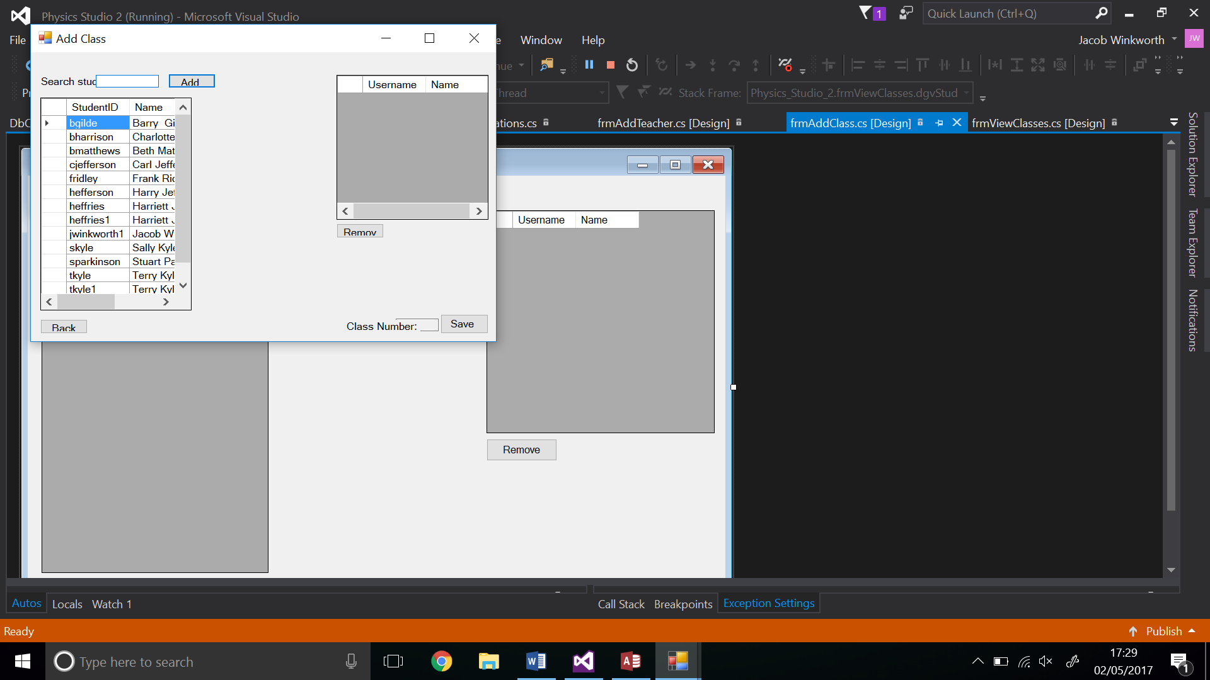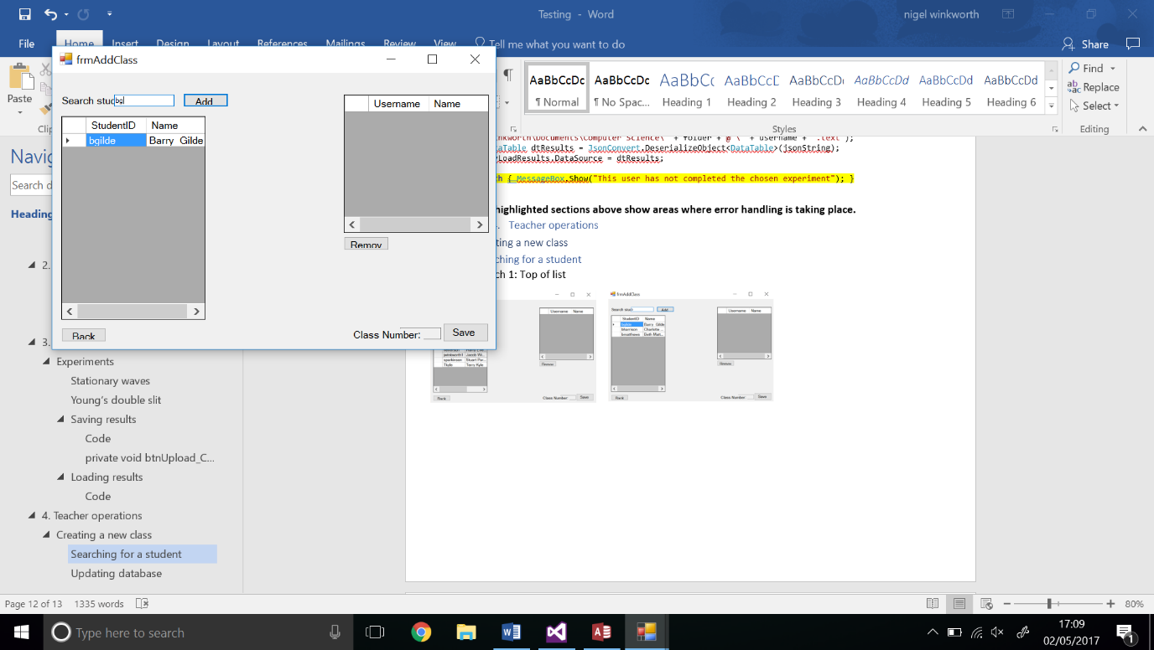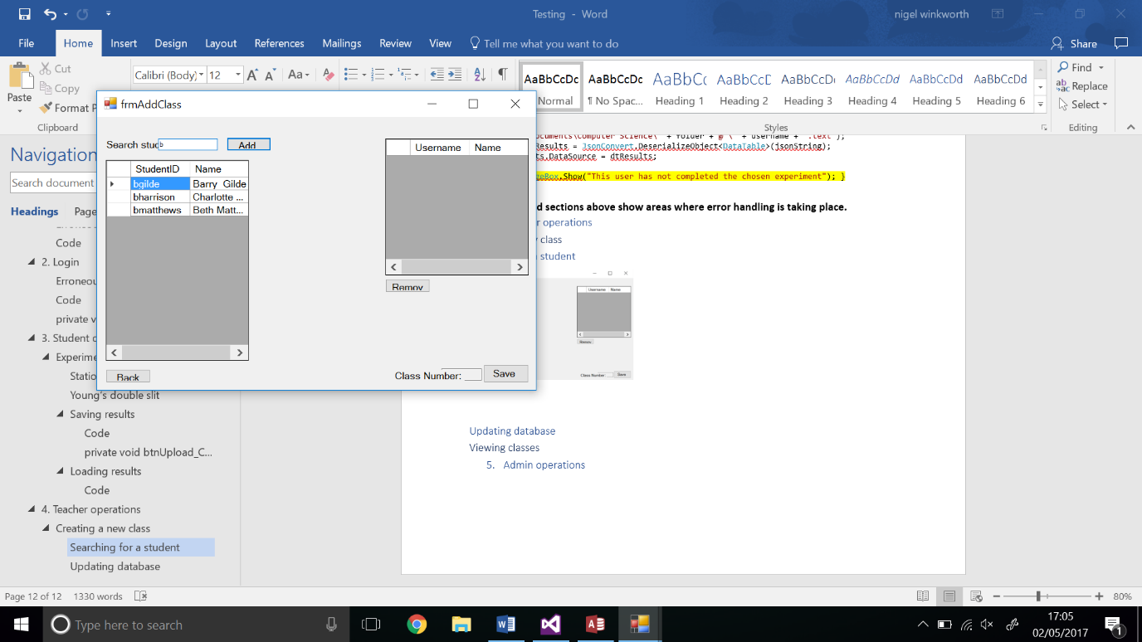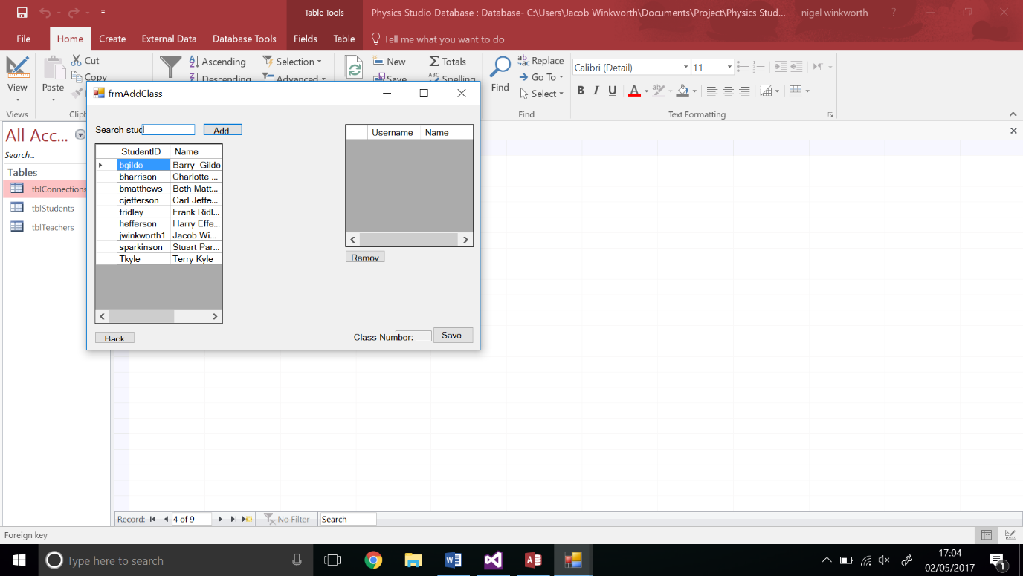Search 1: Simple search for bgilde (Key is found after very few input characters)

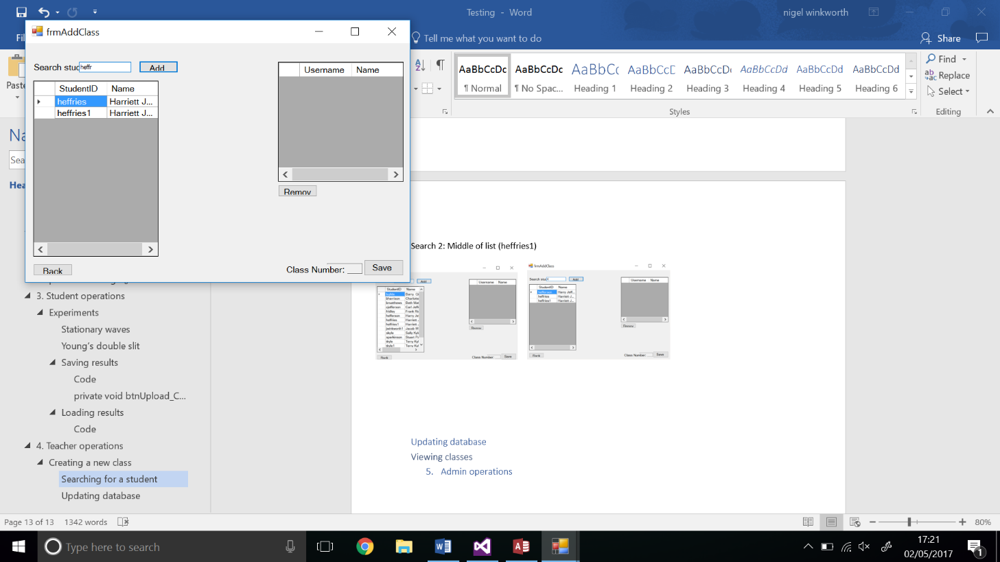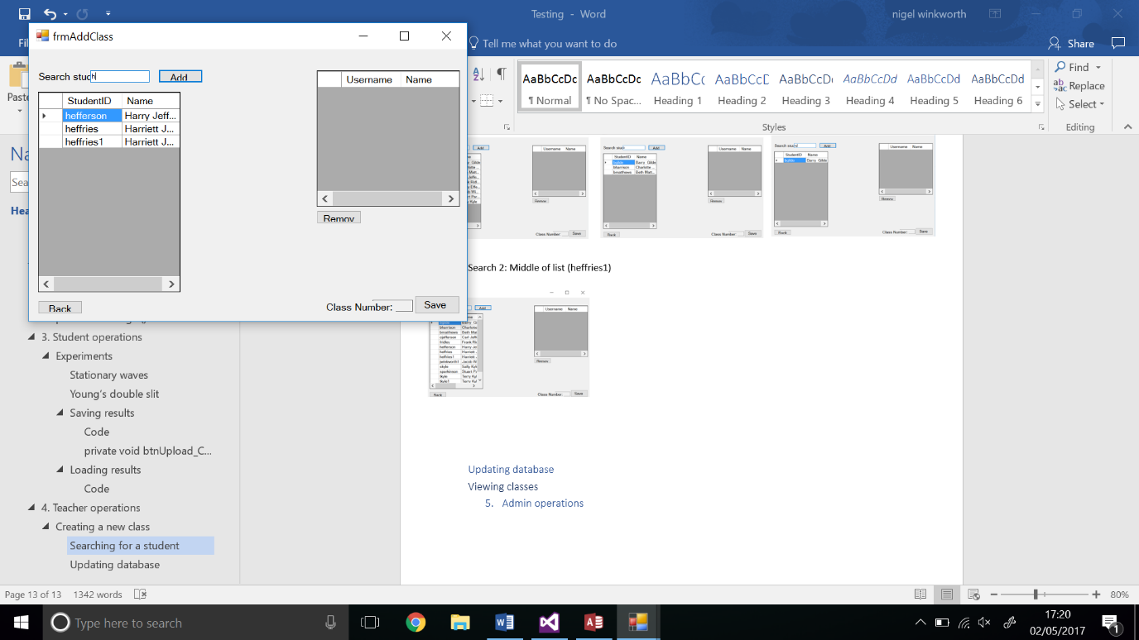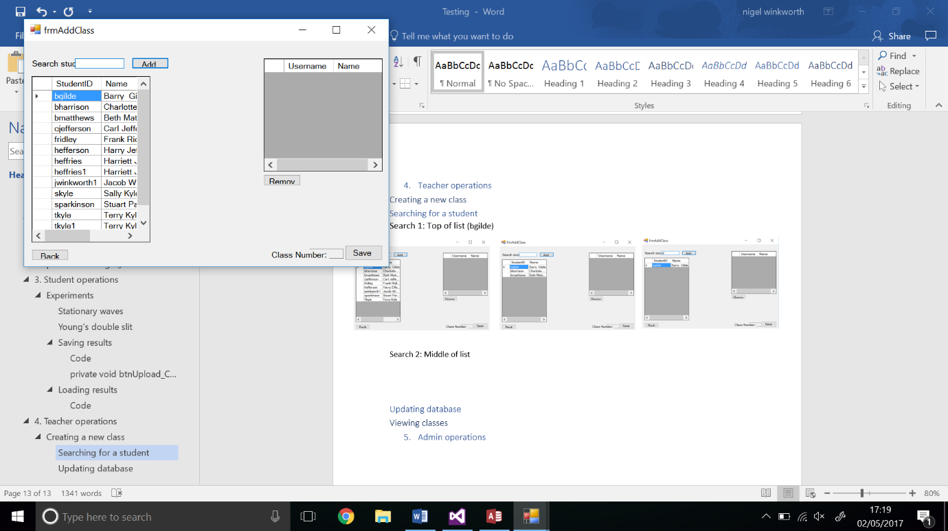Search 2: Complex search for heffries1 (Key is found after all characters are input as similar IDs exist)

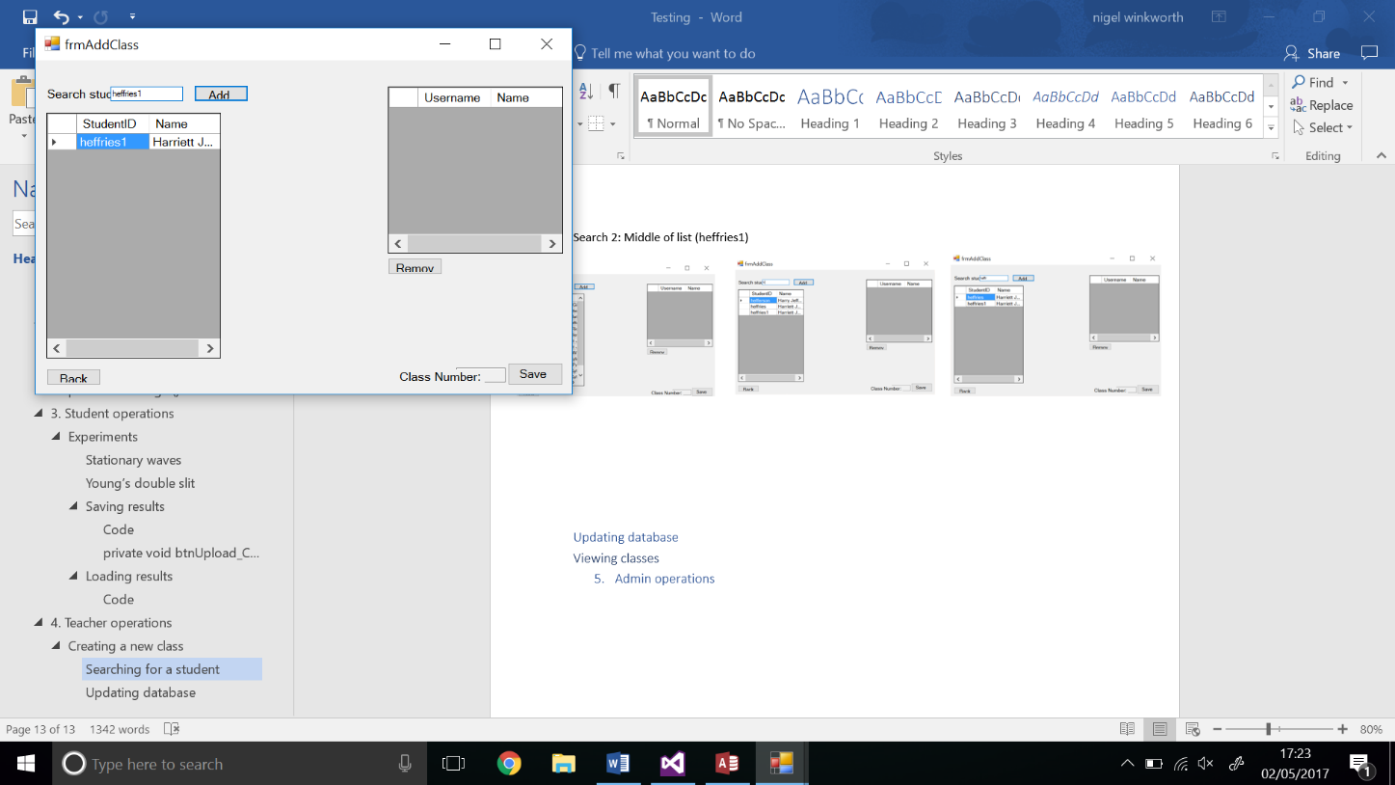

#### Updating database

### Viewing classes

## Admin operations